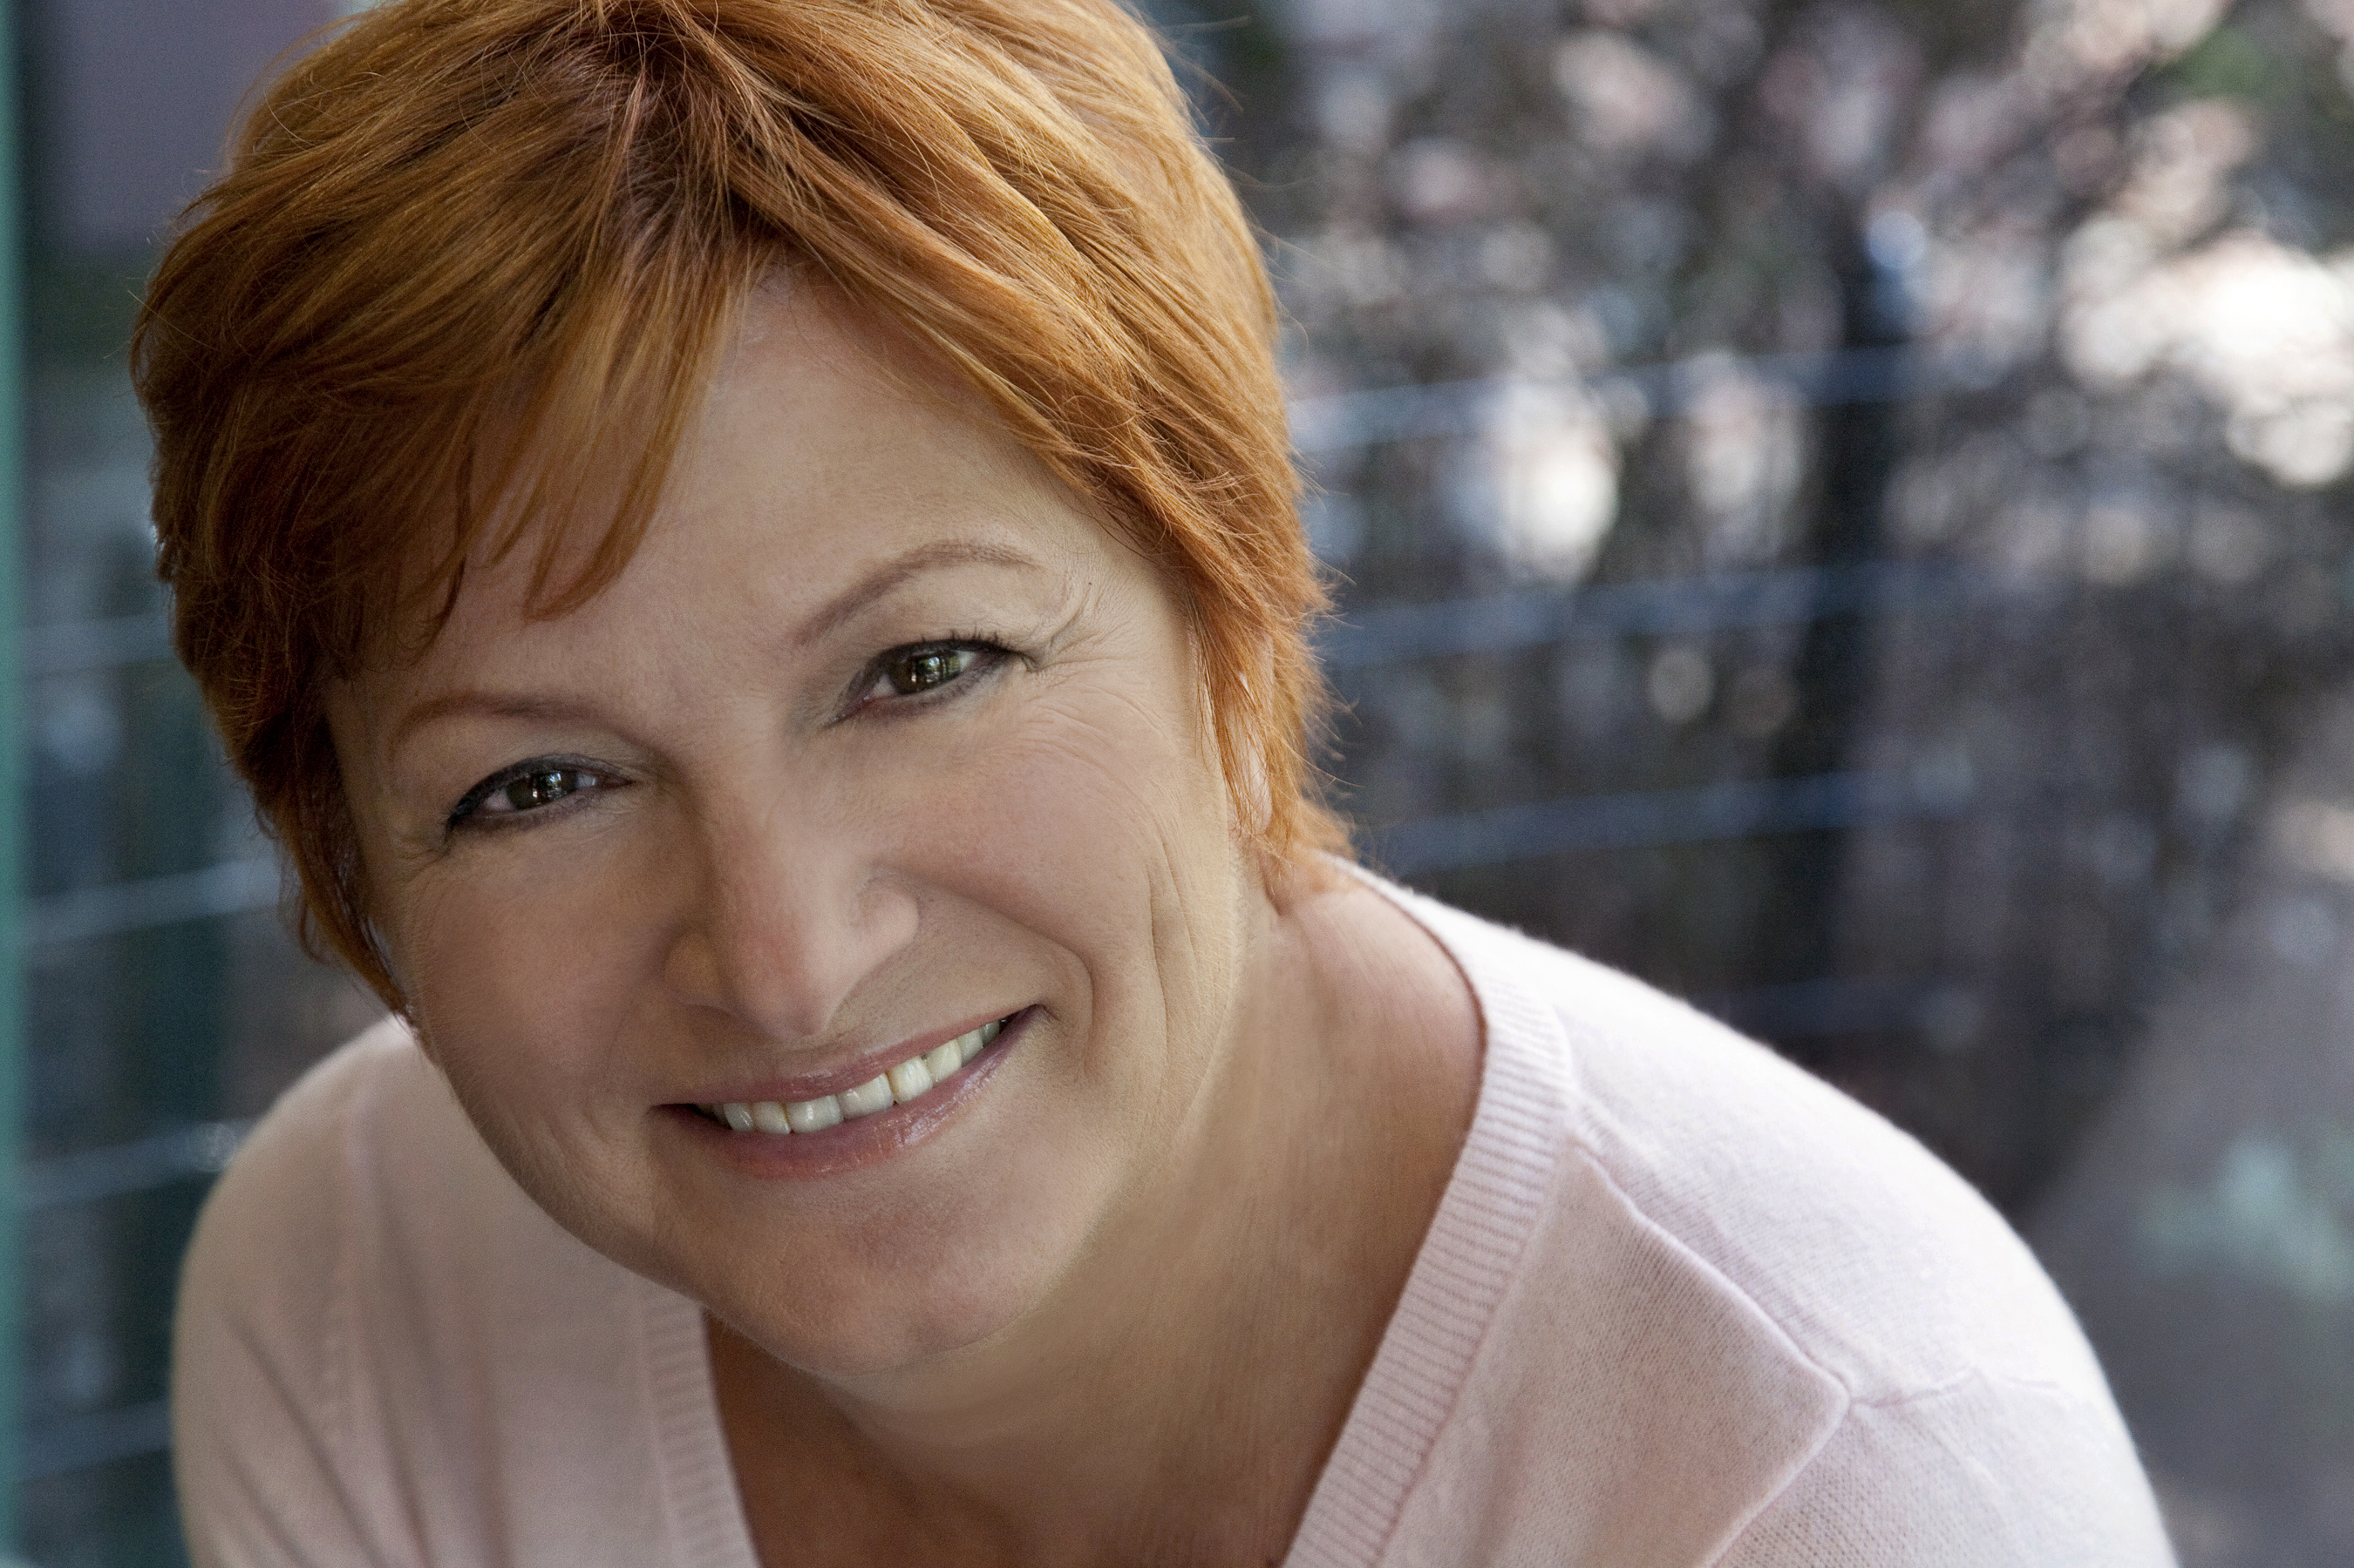
FRANCES McGARRY
fmcgarry@optonline.net
www.francesmcgarry.com
www.firstonlinewithfran.com
SAG eligible

(631) 796-4056 (C) Dress Size 8
(631) 754-3069 (H) Height: 5' 2"
Vocal Range: Alto
Theatre
Lie of Omission Alice(Mom) Studio Thtr., LI
My Occasion Of Sin Helen Hollewski Stage Left Studio
I Witness Sheila 13th St. Rep
Dear Mom Mom Thtr For New City
The Vagina Monologues Reclaiming C*** Here Arts Center
The Reason For Play' Eve Roy Arias Studio
Freshplay Festival Nancy MCC Theater, NYC
My Left Breast Susan Triad Theater, NYC
The Vagina Monologues The Flood Triad Theater NYC
The Children's Hour Lily Mortar Regional Theater
The Last Night Of Ballyhoo Beulah Levy Regional Theater
You Can't Take It With You Penny Sycamore Community Theater

Television/Film
Two Many Moms, Pilot Mom Gene Fisch Jr, Dir.
My Dirty Little Secret Mother Red Marble Media
Investigate Discovery Featured Mother Picture Shack Ent.
School Spirits Waitress Jarrett Creative
Celebrity Ghost Series Grandma Darwish Charlie Mysak, Dir.
The Fever & The Fret HS English Teacher Cath Gulick, Dir.

Voiceover
Product X Pharmaceutical Patient The Napoleon Group
NYU Bluestone Research VO Bluestone Ctr. NYU
Reasonable Doubt/Vo Susan Dean, Defense Atty. Largervisions Inc.

Commercial/Print Available Upon Request

Education/Training
Theater Education (Ph.D.) New York University
Alaine Alldaffer 5 Week Class Showcase
Camille Hickman Lincoln Center Theater Intensive
Bob Krakower Acting Workshop
Amy Gossels On-Camera Intensive Workshop
David Vaccari Feature Film Intensive Workshop
Jenevieve Brewer On-Camera Audition Technique Workshop
Brooke Thomas/Mary Callahan Auditioning & Networking Commercial CDs
Julie Tucker Booking Co-Star & Guest Star Roles

Skills
K-12 English/Theatre Teacher, Adjunct Professor NYU Steinhardt
First Online With Fran, Producer/Blogger/YouTube Talk Host
Published Author, Conference Presenter, New York/Long Island/Irish/Southern Accent
Aerobics, Yoga, Horseback Riding(English), Ballet, Basic Piano

Miscellaneous Valid Us Passport, NYS Driver's License

